Western Province Rottweiler Club



JUDGE’S CRITIQUE

CATALOGUE NO. 33
DATE. 25 October 2003
NAME OF DOG. VONGERSHAN CASIA
KUSA REG NO. BT008755
CLASS: Graduate
TATTOO NO:
MICROCHIP NO: 43245F6051

COMMENTS:
Medium to large bitch, easy temperament, good substance, strong bone, well muscled, strong head, brown eyes, dark flews, slight pink fle<*£>in gums, well set ears, good front and rear angulation, deep broad chest, strong fore legs and paws, good top and bottom lines, well muscled thighs, well groomed coat, rust coloured markings with pencil marks on toes, free flowing movement, slightly restricted.

GRADING.
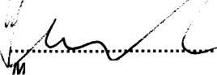

JUDGE.
MR D BENNET (GAUTENG)

