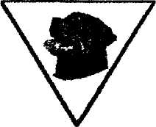
Highveld Rottweiler Club
Affiliated to The Kennel Union p.o. Box 1448
of Southern Africa Bedfordview
2008
17^{h} Championship Show - 10th May 2003
JUDGE: MR. CHRIS PRETORIUS
Catalogue Number: 24 Class: OPEN
Dog's Name: MIPRET DINGO OF VONGERSHAN (HDOO) Registration Number: BR006244 ID Number: 43276B092A
CRITIQUE GENERAL APPEARANCE:
MEDIUM LARGE WELL PROPORTION MALE - FRIENDLY WITH A BROAD SKULL - SOMEWHAT NARROW MUZZLE - EARS MEDIUM / LARGE WELL PLACED & CARRIED - DARK BROWN EYES - DARK PIGMENT -MUSCULAR NECK - GOOD ROOMY CHEST & BROAD FORE CHEST -GOOD TOP & BOTTOM LINE - VERY WELL ANGULATED REAR FORE AND OFT - TIGHT TOES ALL ROUND - MOVES TRUE AND ENERGETICALLY WITH GOOD REACH & DRIVE - SCISSOR BITE

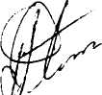
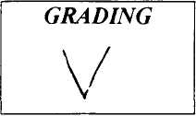
Judges Signature
CHRIS PRETORIUS

