ROTTWEILER
Working and Breeding Association

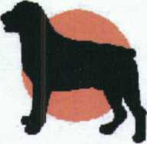

Judge's Critique
Date: 19 July 2003
Entry number: | 19
Dog's name: | Vongershan Danjo
KUSA Reg. No.: | BU000790
Tatoo / Microchip no: | 442D65374C
Owner/s: | Mrs. S Smit
Judge: | Mr. Terje Lindstrom
Comments:

Medium size, very good substance, masculine, very good head and expression, short compact body, full dentition and correct bite, would like a better lay back of shoulder and upper arm, moderate angulation in rear end, correct coat and tan markings, moves with good reach and drive, little bit loose in front, need to tighten up in top line and movement.
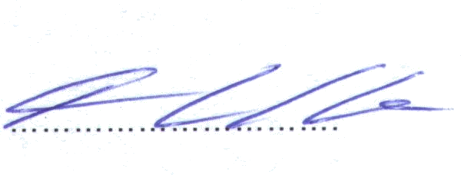
Grading: SG3 Judge:

